1. 
2. 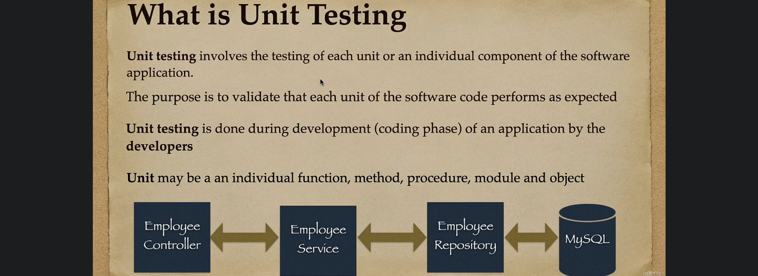
3. A close up of a paper

   Description automatically generated with low confidence
4. A picture containing text, screenshot, font, number

   Description automatically generated